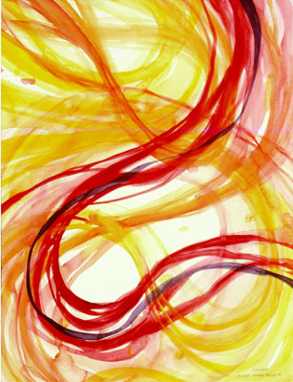

Movement
The principle of art used to create the look and feeling of action and to guide the viewers eyes throughout the work of art.
M.C. Escher is one of the many artists who use movement constantly in his artwork.

